21.44: A positive and negative charge, of equal magnitude , are on the x-axis, a distance from the origin.
a) Halfway between them, 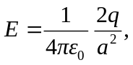 to the left.
b) At any position 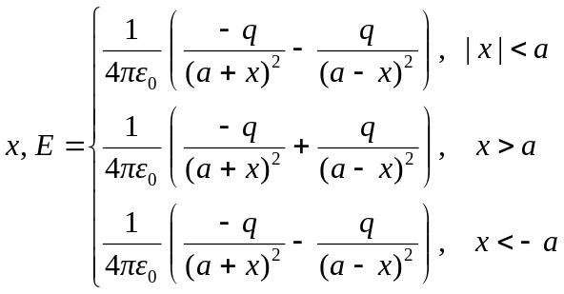
with “+” to the right.
This is graphed below.

